Project Design Phase-II

Data Flow Diagram & User Stories

Date | 11 February 2026
Team ID | LTVIP2026TMIDS54303
Project Name | Online Payment Fraud Detection using Machine Learning
Maximum Marks | 4 Marks

Data Flow Diagrams:
A Data Flow Diagram (DFD) is a traditional visual representation of the information flows within a system. A neat and clear DFD can depict the right amount of the system requirement graphically. It shows how data enters and leaves the system, what changes the information, and where data is stored.

Example: (Simplified)
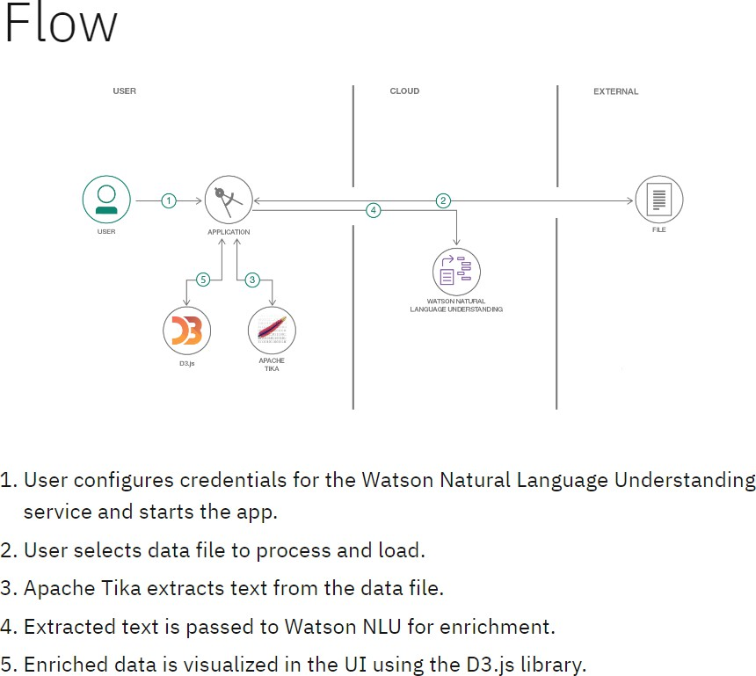

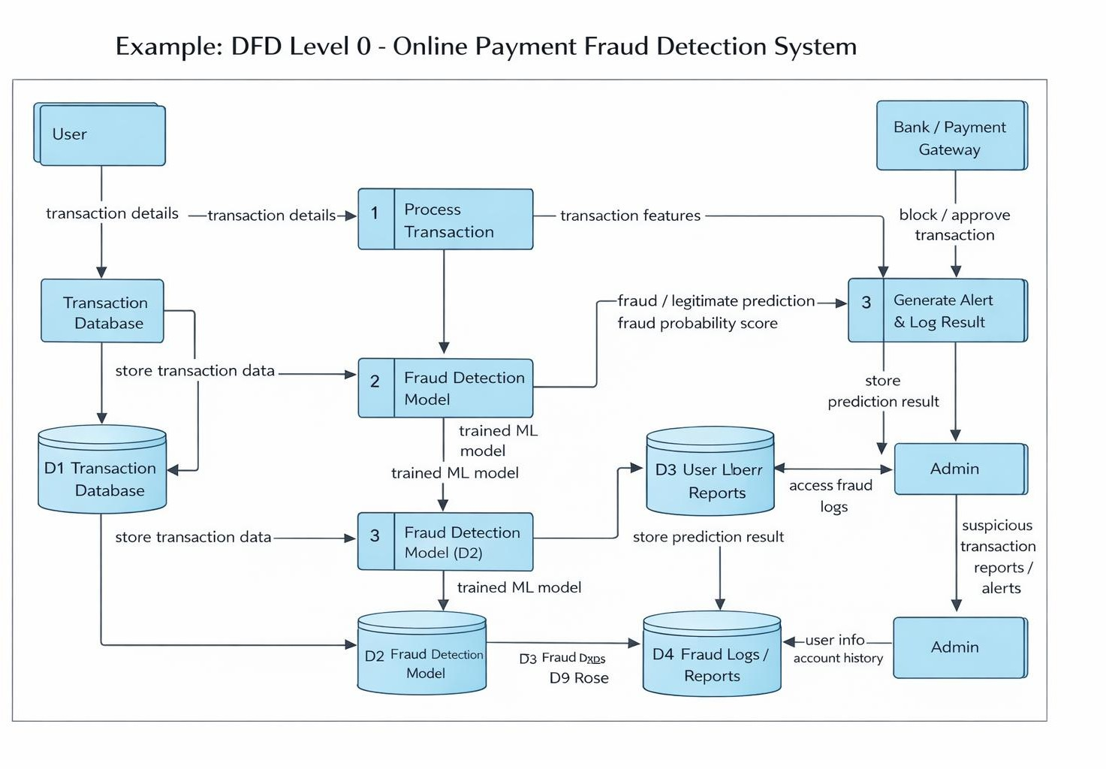

User Type | Functional Requirement (Epic) | User Story Number | User Story / Task | Acceptance Criteria | Priority | Release
Customer | Fraud Monitoring | US-1 | As a customer, I want to receive real-time alerts when a high- risk transaction occurs on my account. | System sends instant notification (SMS/App/Email) for risky transactions. | High | Sprint-1
Customer | Transaction Transparency | US-2 | As a customer, I want to view the risk score of my recent transactions. | User can see fraud probability score and transaction status. | High | Sprint-2
Customer | Account Security | US-3 | As a customer, I want the system to temporarily block  suspicious | Suspicious transaction is placed on hold until user confirmation. | High | Sprint-1

 |  |  | transactions until I verify them.
Customer | Authentication | US-4 | As a customer, I want secure login using two- factor authentication. | User logs in using password + OTP verification. | High | Sprint-1
Fraud Analyst | Monitoring | US-5 | As a fraud analyst, I want to review flagged transactions in a centralized  dashboard. | Analyst can filter transactions by risk level, date, and user. | High | Sprint-2
Fraud Analyst | Investigation | US-6 | As a fraud analyst, I want to see detailed transaction patterns for suspicious accounts. | System displays transaction history and anomaly indicators. | High | Sprint-3
Administrator | Reporting & Analytics | US-7 | As an admin, I want to generate monthly fraud detection performance reports. | Admin can download reports showing precision, recall, F1-score, and accuracy. | High | Sprint-3

